SugarCRM registration

1. Go to https://www.sugarcrm.com/.
2. Click on button "FREE TRIAL".
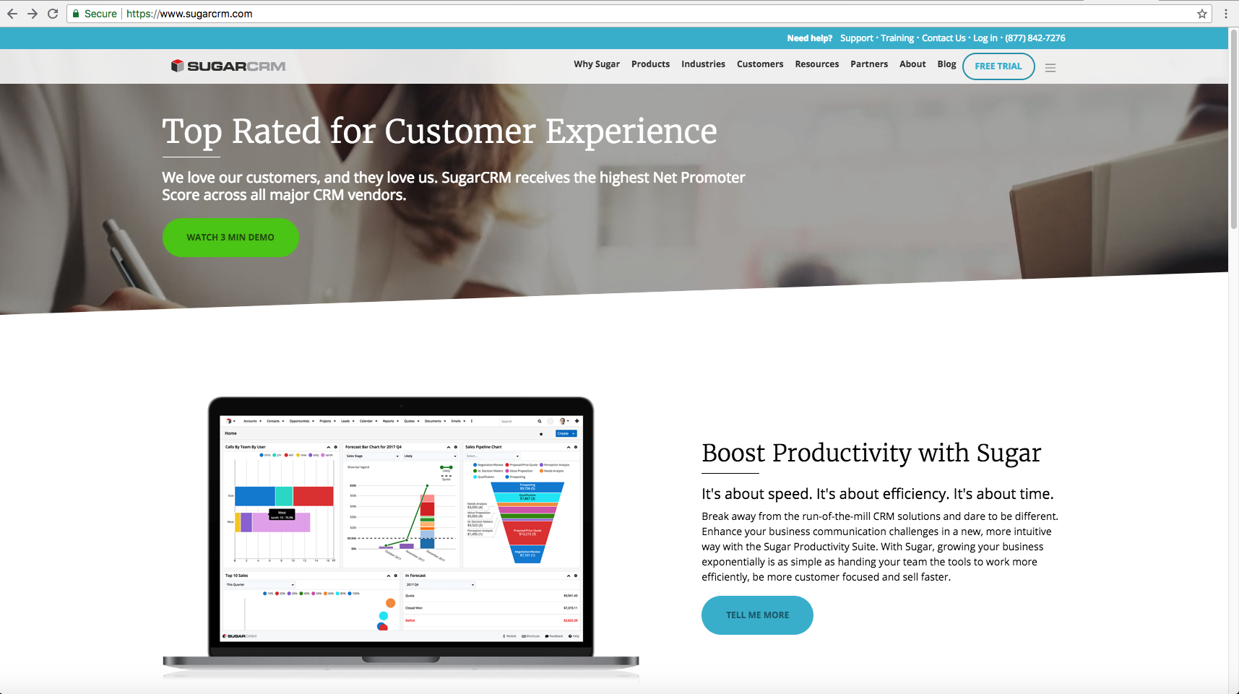
3. Fill the fields and click on button "Start Your Free Trial".
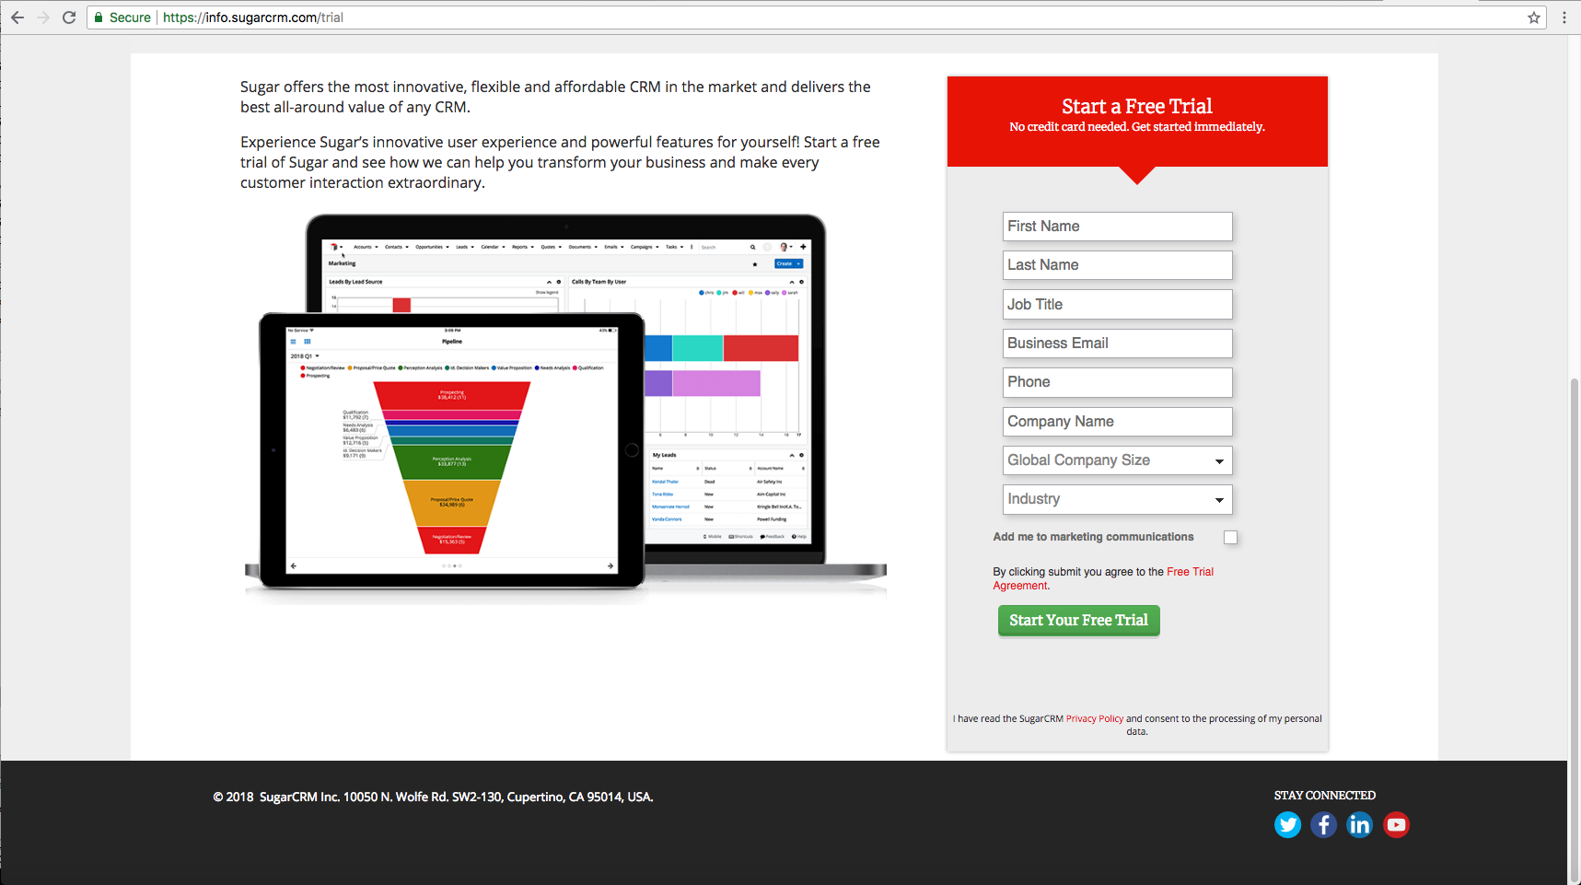
Note. Use corporate e-mail, for example: tom@mycorp.com.

4. Then you will be redirected to the next page.
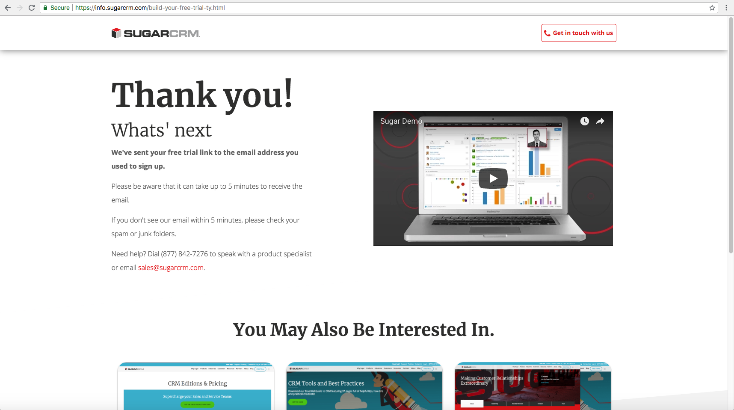
5. Go to your e-mail box and find the e-mail from "SugarCRM".
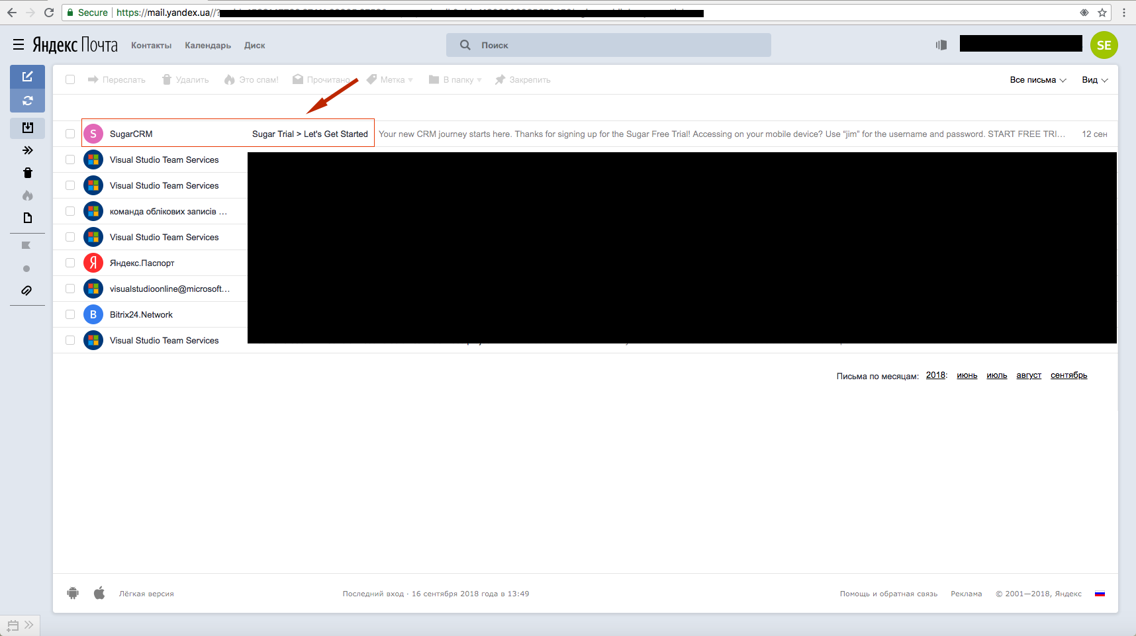

6. Click on the button "START FREE TRIAL".
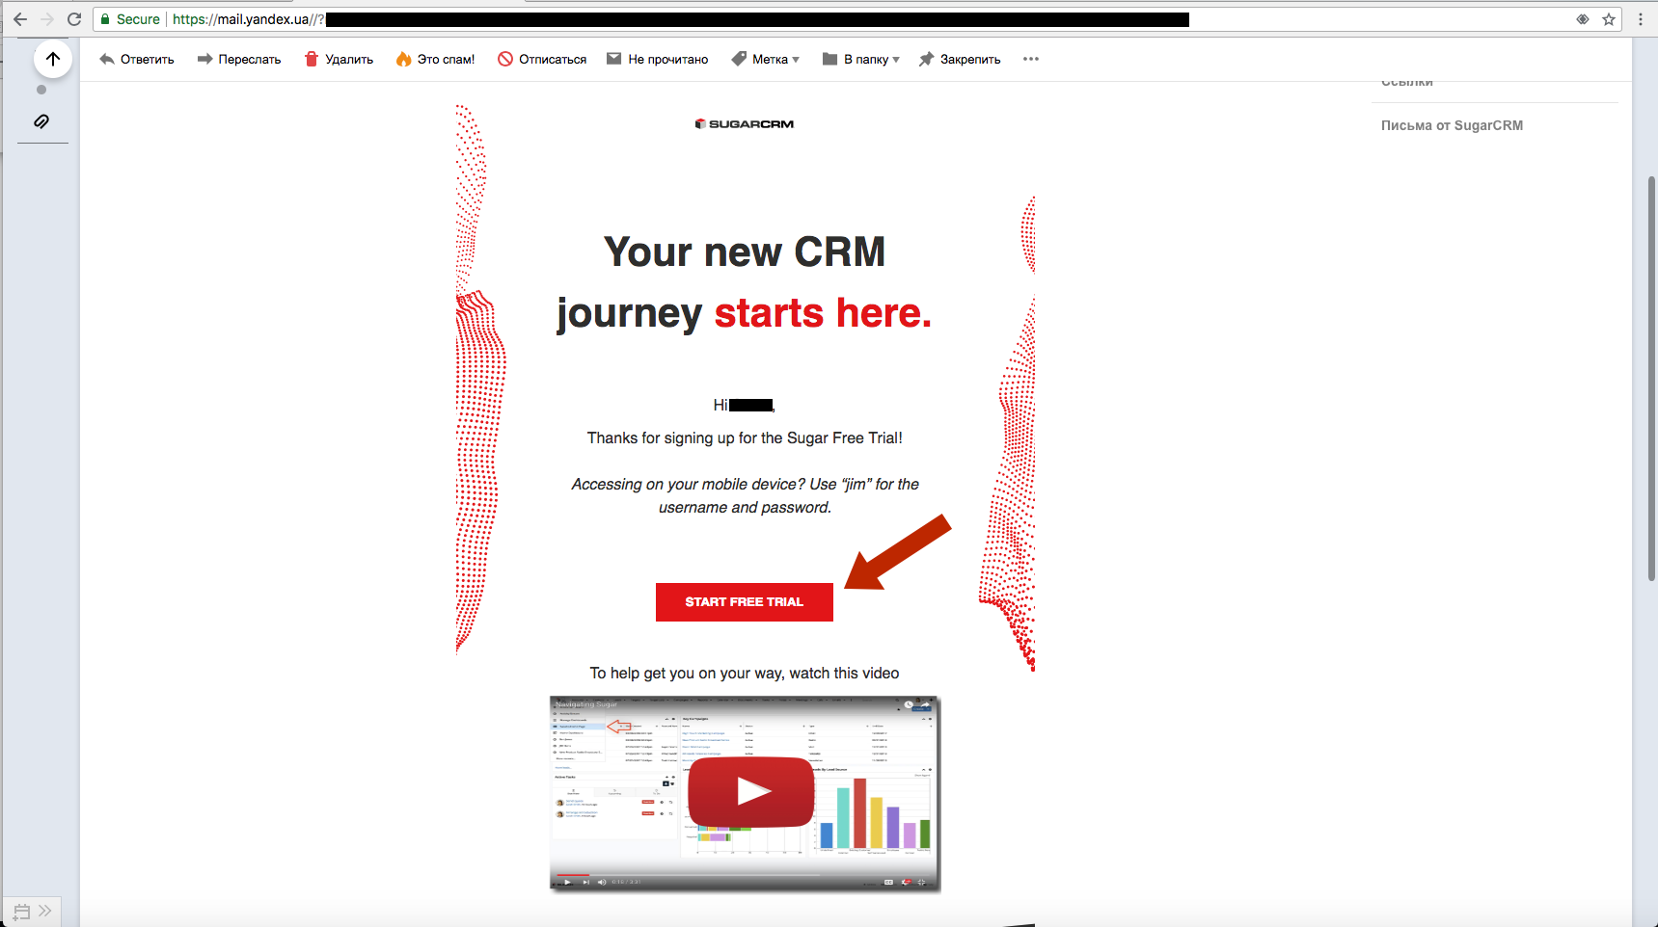
7. After that you will be redirected to the trial website, login as ‘admin’.
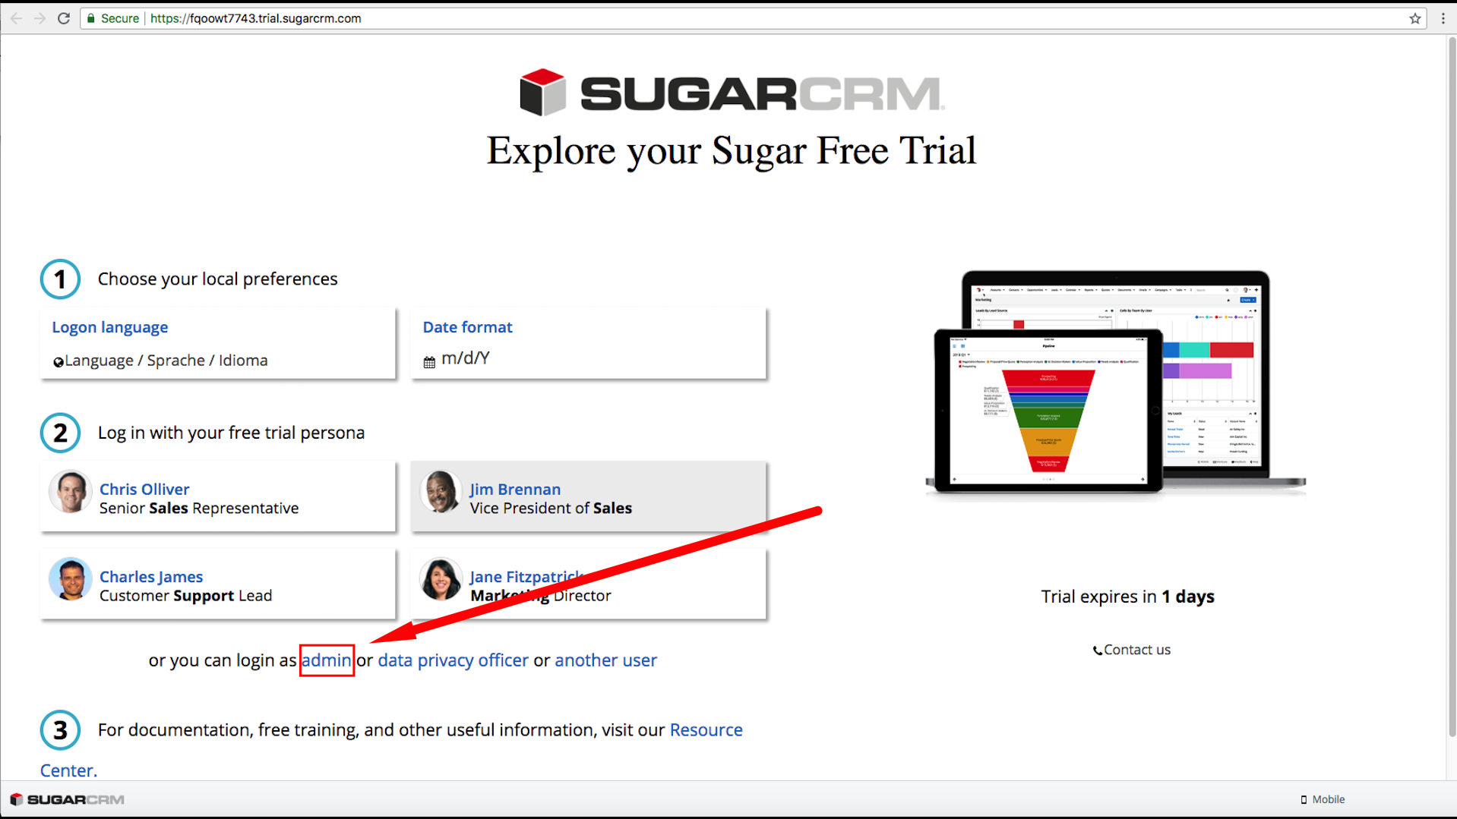

8. Go to the profile and select "Administration".
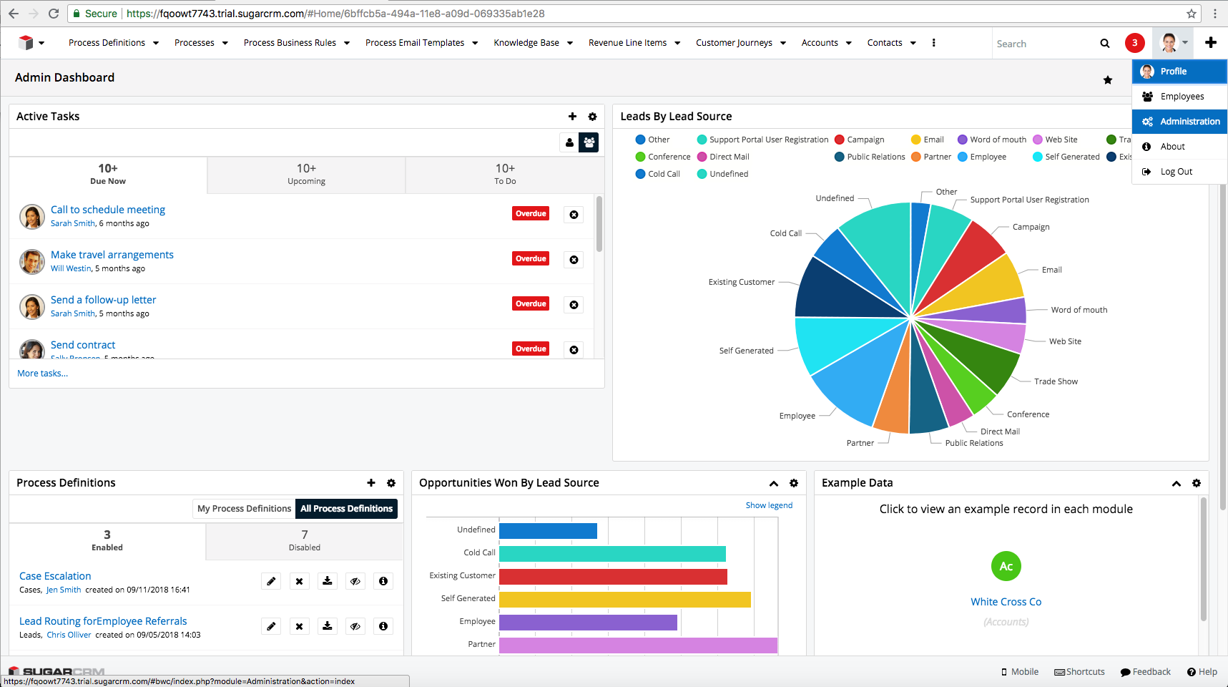
9. In the next page click on the link "OAuth Keys".
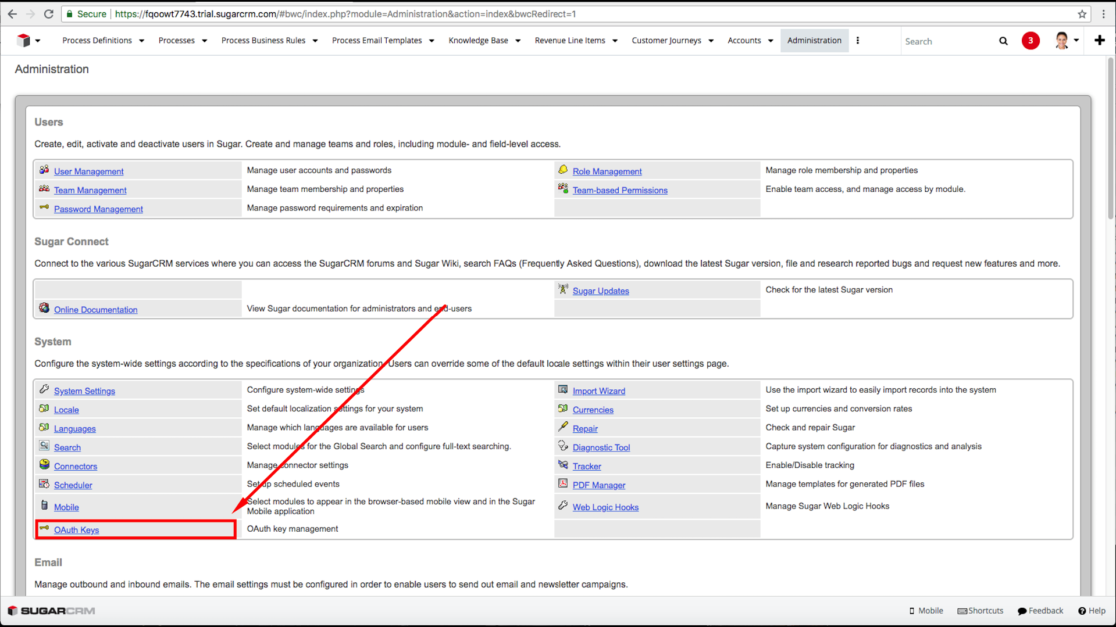

10. Then create OAuth key.
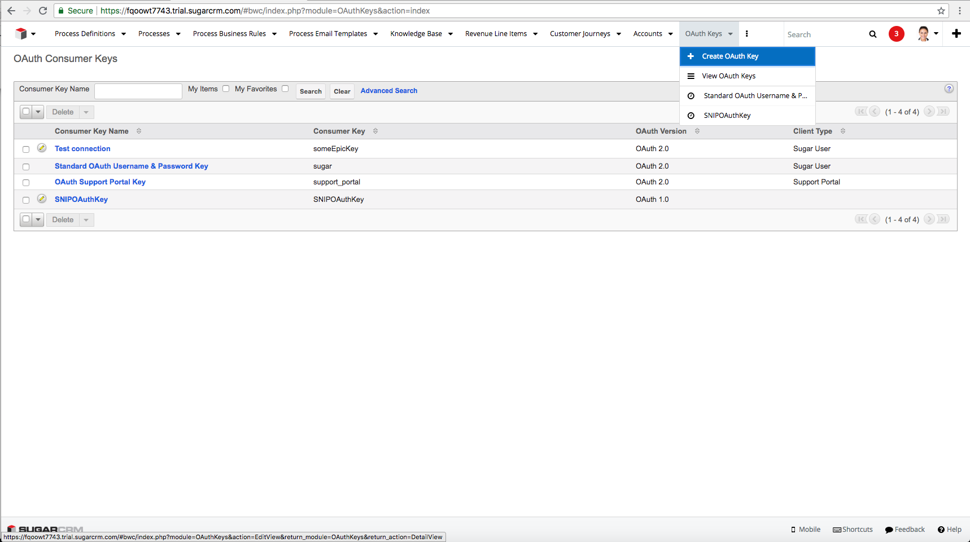
11. Select OAuth version.
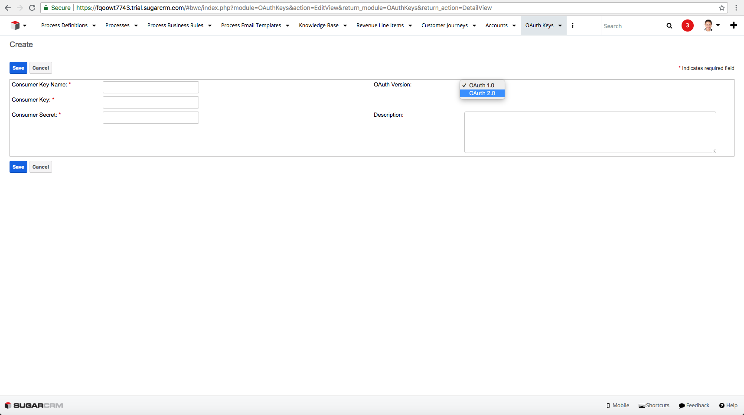

12. Fill all fields.
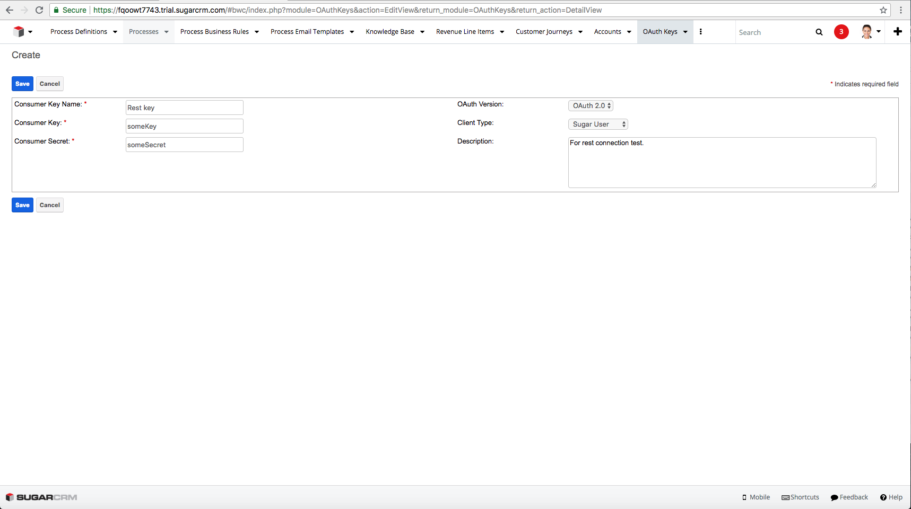
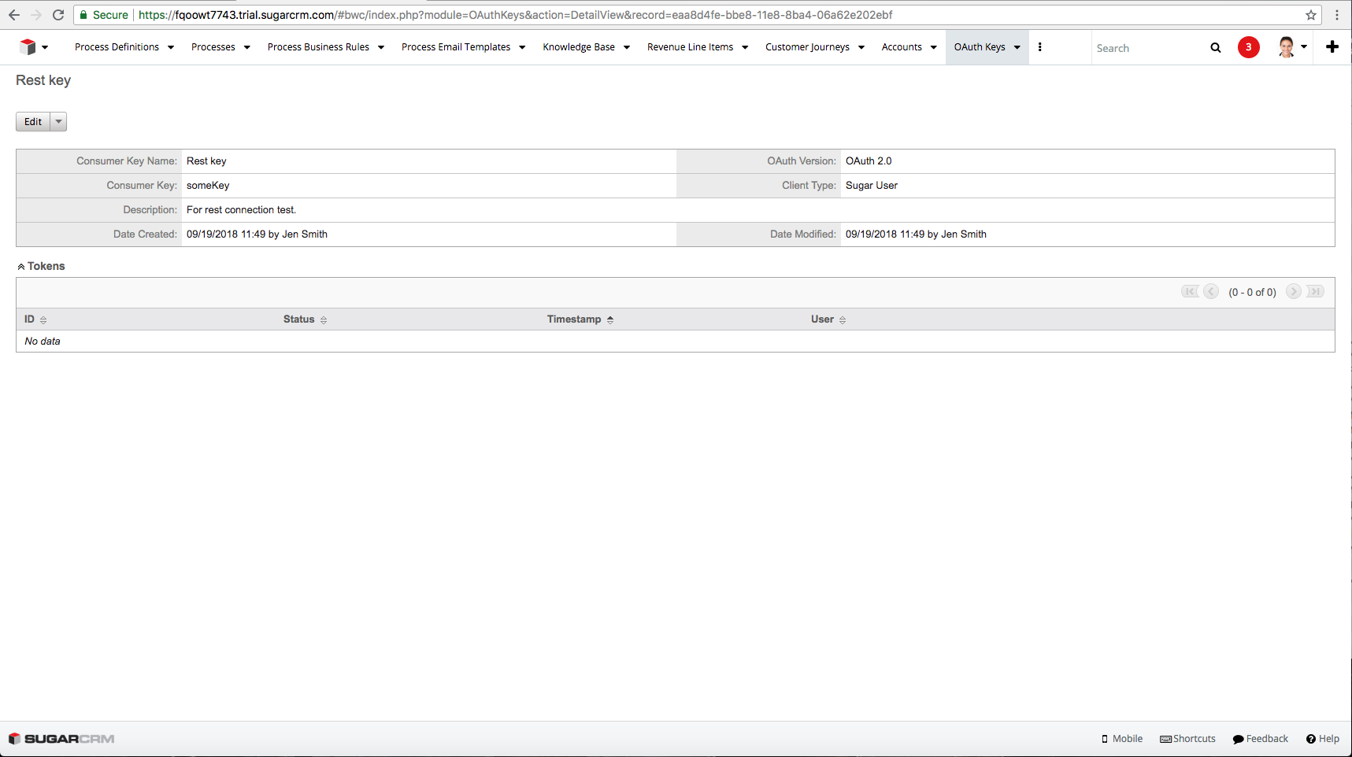
Copy your consumer Key and Secret key to your App, save your OAuth Key.
Good Luck!

